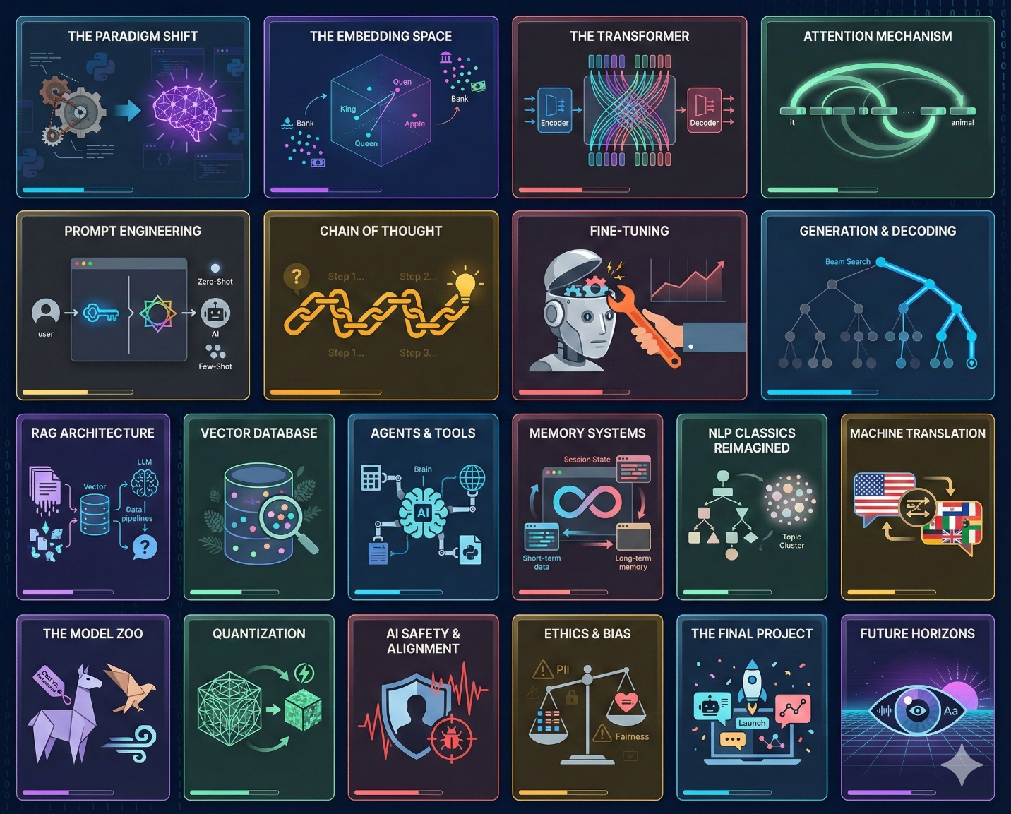
Week | Dates | Module | Topic | Due Date
1 | Jan 12 – 18 | Mod 0 & 1 | Course Intro & The LLM-First World  Pre-Transformer vs. Post-Transformer NLP | Mon, Jan 19*  (MLK Day)
2 | Jan 19 – 25 | Mod 2 | Text Representation  From TF-IDF to Contextual Embeddings | Mon, Jan 26
3 | Jan 26 – Feb 1 | Mod 3 | The Engine: Transformers  Self-Attention, Encoders, & Decoders | Mon, Feb 2
4 | Feb 2 – 8 | Mod 4 | Prompt Engineering  Zero-shot, CoT, & DSPy | Mon, Feb 9
5 | Feb 9 – 15 | Mod 5 | Fine-Tuning (Specialization)  NER & Classification on the Edge | Mon, Feb 16
6 | Feb 16 – 22 | Mod 6 | Generation & Summarization  Decoding Strategies & LoRA/PEFT | Mon, Feb 23
7 | Feb 23 – Mar 1 | Mod 7 | Retrieval Augmented Generation (RAG)  Vector DBs & Grounding | Mon, Mar 2
8 | Mar 2 – 8 | Mod 8 | Chatbots & Agents  Memory, Tools, and Agent Frameworks | Sun, Mar 8*  (Due before Break)
-- | Mar 9 – 15 | BREAK | SPRING BREAK | No Due Dates
9 | Mar 16 – 22 | Mod 9 & 10 | Syntax & Topic Modeling  Knowledge Graphs & Semantic Clustering | Mon, Mar 23
10 | Mar 23 – 29 | Mod 11 | Machine Translation  NMT & Multilingual Models | Mon, Mar 30
11 | Mar 30 – Apr 5 | Mod 12 | The LLM Ecosystem & MLOps  Quantization, Edge AI, & Cost | Tue, Apr 7*  (Adjusted for Spring Holiday)
12 | Apr 6 – 12 | Mod 14 | Ethics, Safety & Alignment  Bias, Jailbreaking, & Red Teaming | Mon, Apr 13
13 | Apr 13 – 19 | Mod 15 | Multimodality & Future Trends  Vision-Language Models (VLM) | Mon, Apr 20
14 | Apr 20 – 26 | Project | Final Project Sprint 1  Implementation & Prototyping | Mon, Apr 27
15 | Apr 27 – May 3 | Project | Final Project Sprint 2  Evaluation & Refinement | Mon, May 4
16 | May 4 – 10 | Mod 16 | Course Wrap-Up  Final Presentations | Fri, May 8

